**Session report 13/03/2023:**

*LABAUVIE – RAFFAELLI EVA*

*ROB3*

For today’s session I needed to re-model the shovel parts of my trash-collecting wheel.

The idea is to open the side instead of the bottom for this time.

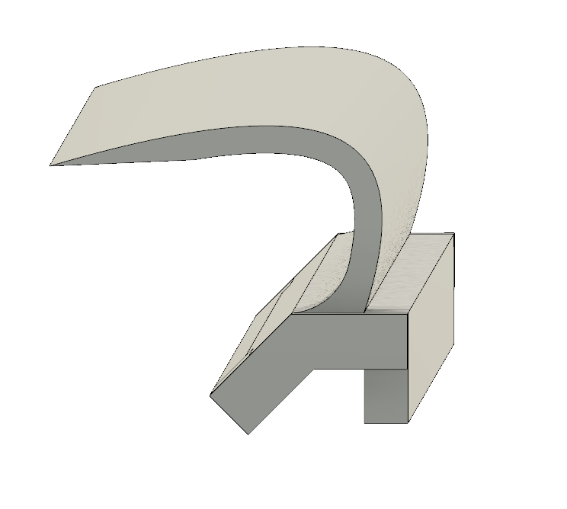

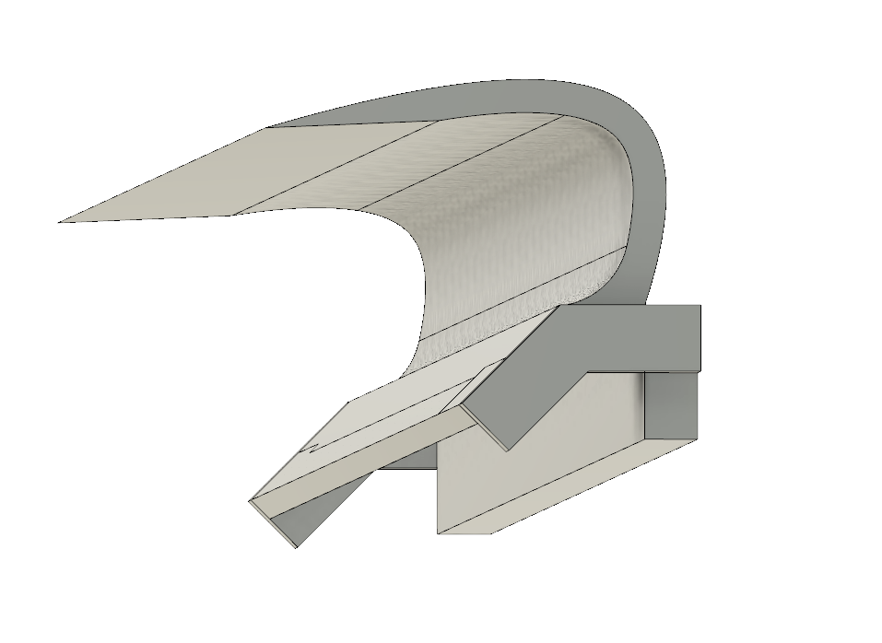

I couldn’t see how to fix it this way to I decided to erase the other face as well and make a “U” looking piece to tie it.

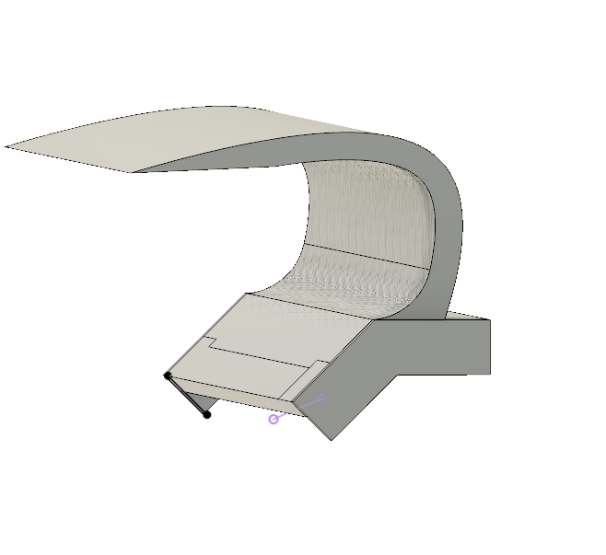

Tha would look like that :

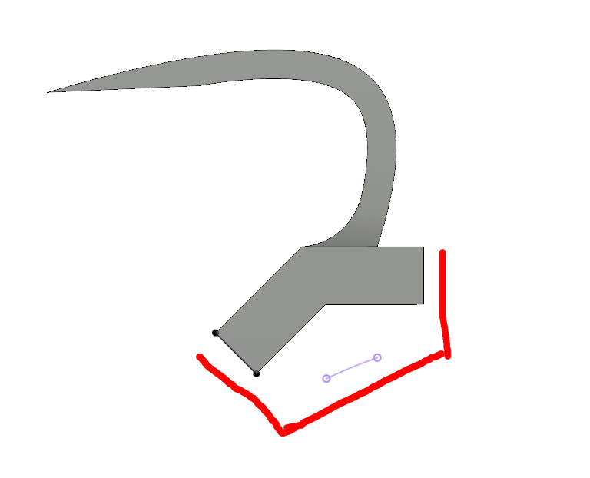

So I will be able to screw on the sides, indicated by the arrows.

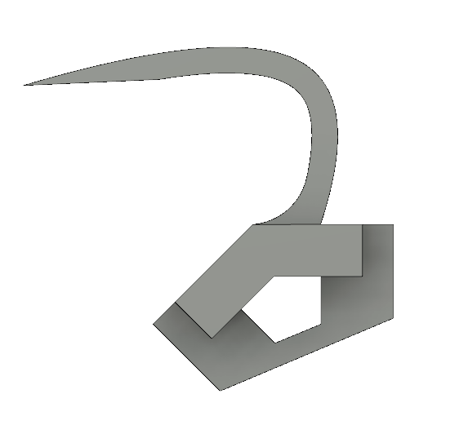*

Here is how it looks like.